SREE CHAITANYA COLLEGE, HABRA
NCC EVENTS
2016 – 2017
- No of NCC Cadets participated in NCC events
- University level:
- Our NCC cadets organized & celebrated Netaji Subhas Chandra Bose’s birth day, Republic Day, College Foundation Day & Independence Day every year in the college campus.
- Every year NCC Cadets Planted trees in our college campus during the Independence ceremony.
- Anti Tobacco rally, rally on Drug Abuse and anti AIDS rally were organized and traveled through the locality.
- The NCC cadets assisted the WBP to control the traffic during Durga Puja and Banipur Lok Utsab.
- State level:
- Each and every year NCC cadets with the help of 6 Bengal Battalion organized a Yoga training camp of three days. Our college has been selected as a nodal college for organizing the training camp. ANO acted as a supervisor.
- All the cadets participated CATC CAMP held at Kalyani to take training.
- National level:
Our NCC cadets were also participated in the following national level events:
- National Integration Camp (NIC): 10 SD Cadets & 08 SW Cadets.
- Special national integration Camp (spl. NIC): 02 SD Cadets & 01 SW Cadet.
- Republic Day Camp: 01 SD Cadet & 02 SW Cadets.
- Thalsena Camp (TSC): 03 SD Cadets & 03 SW Cadets.
- Trekking Camp: 04 SD Cadets & 03 SW Cadets.
- Completed basic and advance mountaineering course from HMI, Darjeeling: 06 SD & 03 SW Cadets.
- International level: Nil

- No of awards won in NCC:
- University level: Nil
- State level: Governor’s medal: SD- 0 & SW- 02
- National level: Nil.
- International level: Nil.
- ‘B’ CERTIFICATE passed: SD-16 & SW-09
- ‘C’ CERTIFICATE passed: SD-06 & SW-03.

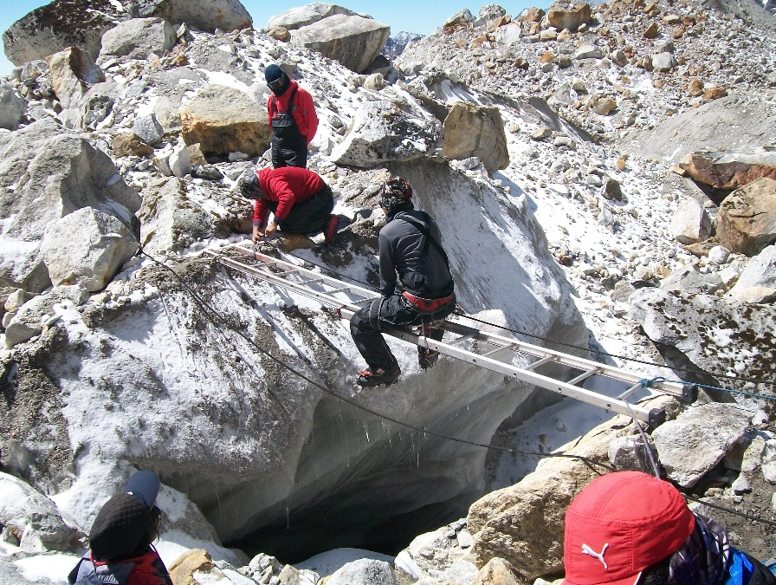
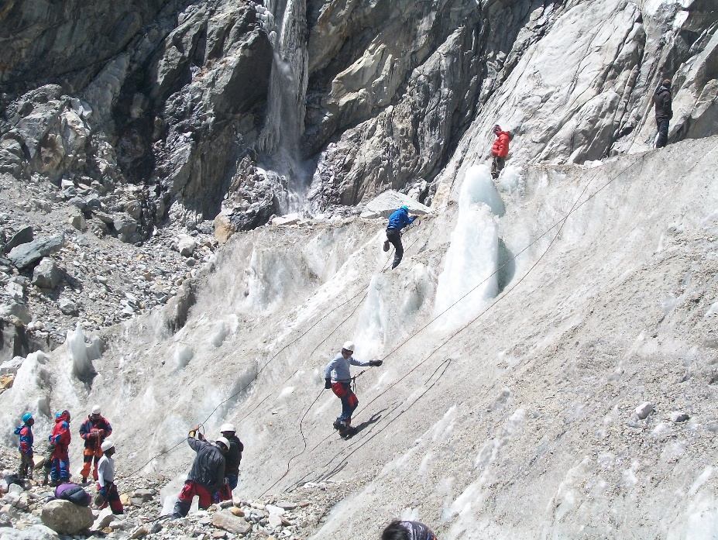
ADVANCE MOUNTERING COURSE ORGANIZED BY HMI DURING
MAY 2016.

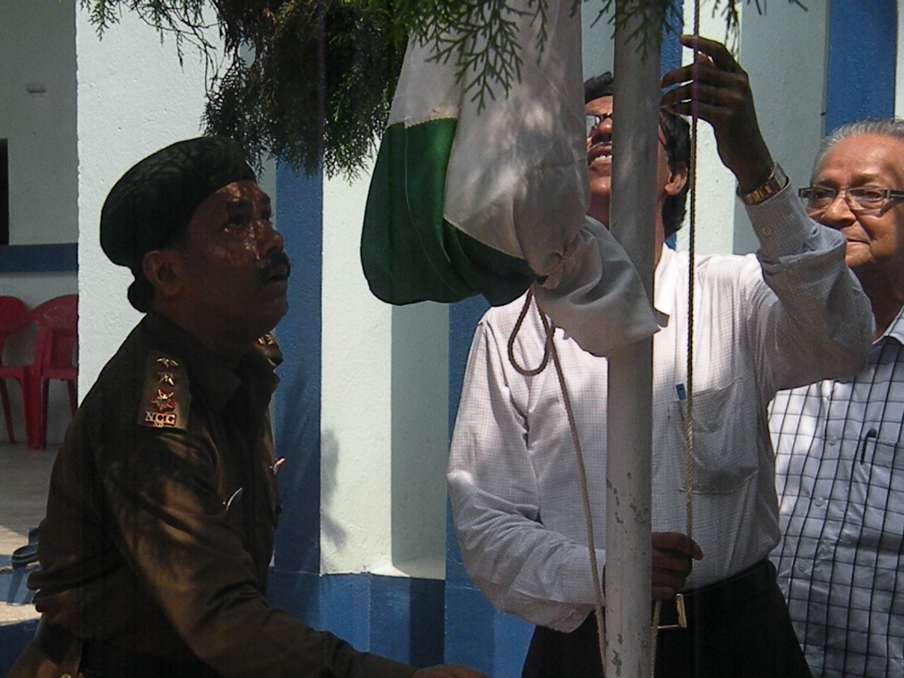
INDEPENDENCE DAY 2016
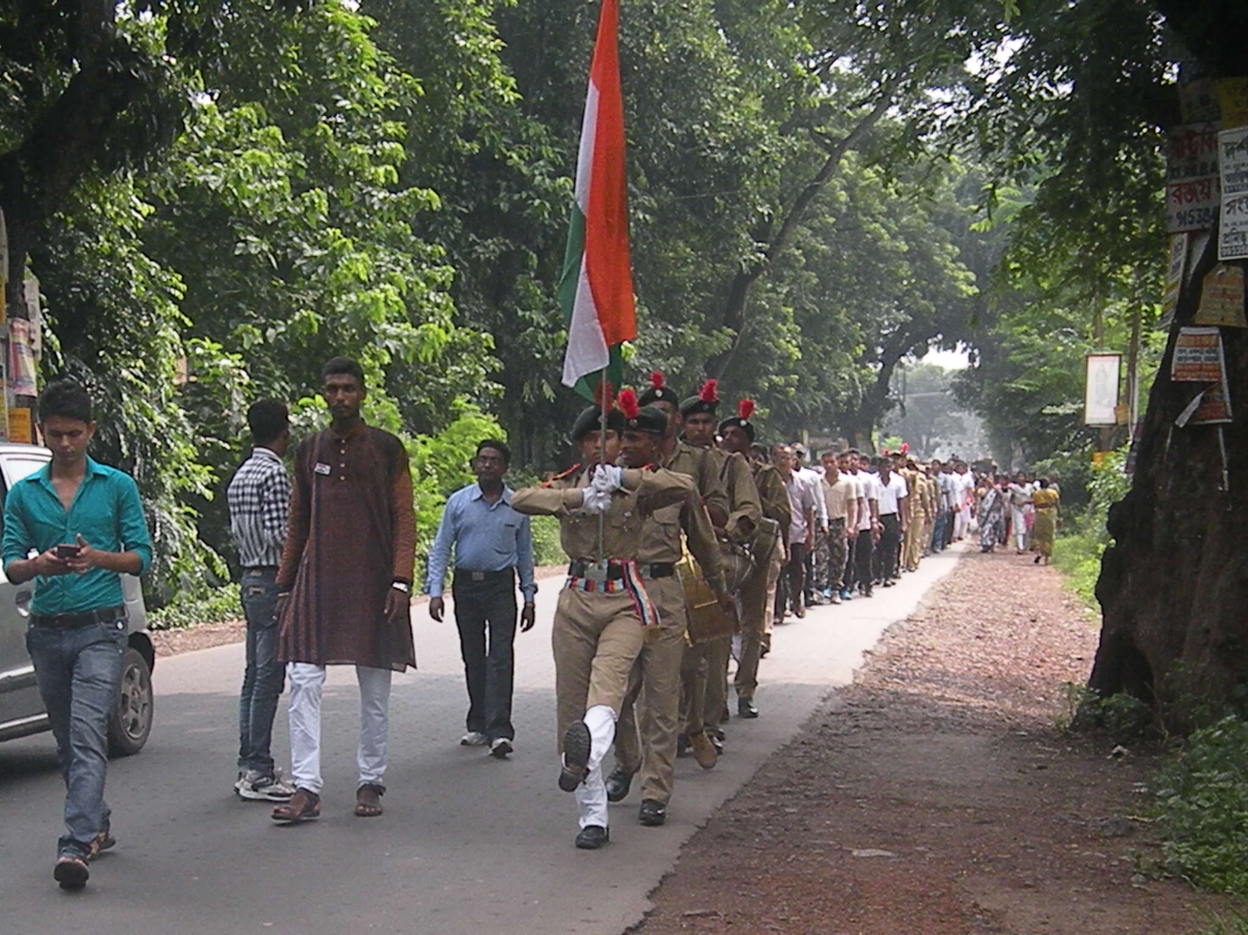
INDEPENDENCE DAY 2016

