SREE CHAITANYA COLLEGE, HABRA
NCC Activities during 2017-2018
Number of extension and outreach programmes conducted in collaboration with industry, community and Non-Government Organizations through NCC during the year 2017-2018
Title of the Activities | Organizing unit/agency/collaborating agency | Number of teachers coordinated such activities | Number of students/cdts participated in such activities
Yoga training camp cum celebration of international yoga day on 21 June | NCC unit (coy no: 04/06) of the college in collaboration with 6 Bengal BN NCC. | 2 Teachers & 1 ANO of the college and 5 ANO of the adjoining schools. ANO Capt. Bedprakash Ray supervised the total programme. | Around 400 cadets were trained through that programme. Among the 400 cdts 160 cdts were college students and 240 cdts were school students of our locality
CATC, TSC, PRDC, TREKKING CAMP etc | NCC GROUP KALYANI, and West Bengal & Sikkim Directorate | One ANO, Capt. Bedprakash Ray | Total 83 cdts.
College foundation day celebration | NCC (coy no: 04/06), NSS units, students and staff. of the college | ANO, Capt. Bedprakash Ray supervised the programme. | About 15 teachers, 20 staff, 1 librarian, 40 students, 100 NCC cdts and 10 NSS cdts were participated
Independence ceremony 2018 and tree plantation | NCC unit (coy no: 04/06) of the college | ANO, Capt. Bedprakash Ray supervised the programme. | About 5 teachers, 20 staff, 1 librarian, 110 NCC cdts were participated
Rock climbing course (Both Basic and Advance) during 22-27 Dec-2017 in Purulia | NCC unit (coy no: 04/06) of the college in collaboration with Pioneer adventure club | ANO, Capt. Bedprakash Ray coordinated the training | 30 cdts were trained.
Netaji Subhas Chandra Bose’s Birth Day ceremony (23.01.2017) | NCC unit (coy no: 04/06) of the college | ANO, Capt. Bedprakash Ray supervised the programme. | About 6 teachers, 15 staff, 1 librarian, 100 NCC cdts and were participated
Republic day Ceremony (26.01.2017) | NCC unit (coy no: 04/06) of the college | ANO, Capt. Bedprakash Ray supervised the programme. | About 5 teachers, 16 staff, 1 librarian, 120 NCC cdts and were participated
Traffic control duty at Banipur Lok utsav | NCC unit (coy no: 04/06) of the college under the control of Habra Police. |  | About 60 NCC cdts were participated.
Mountaineering course | HMI (Himalayan Mountaineering Institute) in collaboration with Department of Youth Services and Sports | ANO, Capt. Bedprakash Ray Coordinated between Department of Youth Services and Sports and cdts | 06 NCC cdts

- Awards and recognition received for extension activities from Government and other recognized bodies during the year.
Name of the Activity | Award/recognition | Awarding bodies | No. of Students benefited
Traffic control duty | Best traffic control duty | Banipur Lokutshav Committee | Nil

- Students participating in extension activities with Government Organizations, Non-Government Organization and Programmes such as Swachh Bharat, Aids Awareness, Gender Issue, etc. During 2017-2018.
Name of the scheme | Organizing unit/agency/collaborating agency | Name of the activity | Number of teachers Coordinated such Activity | Number of students/cdts participated in such activities
Swachh bharat abhijan | NCC unit (coy no: 04/06) of the college | Cleaning the college campus as well as outside of college campus | ANO, Capt. Bedprakash Ray organized the programme several times inside as well as outside of college campus. | About 120 NCC cdts were participated.
The rally Against Drug Abuse and Illicit Trafficking was organized on 26 June 2018 | NCC unit (coy no: 04/06) of the college in collaboration with 6 Bengal BN NCC. | Awareness against Drug Abuse to the local people | ANO, Capt. Bedprakash Ray supervised rally. | About 150 NCC cdts were participated in the rally.

Signature of ANO
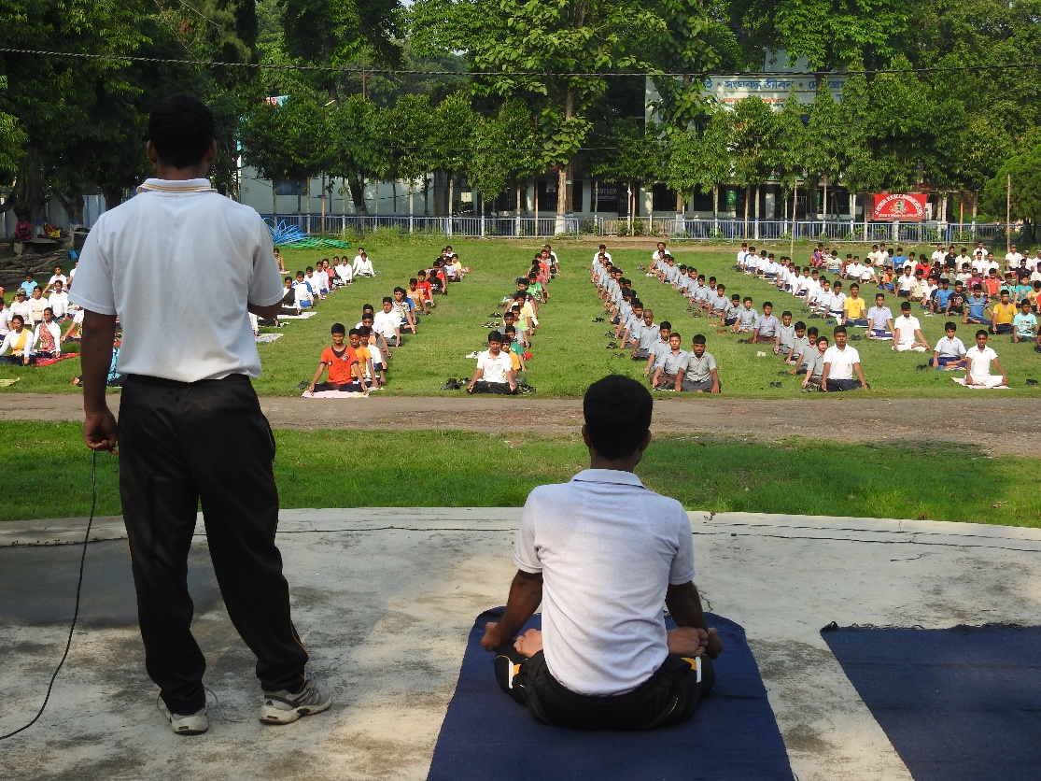
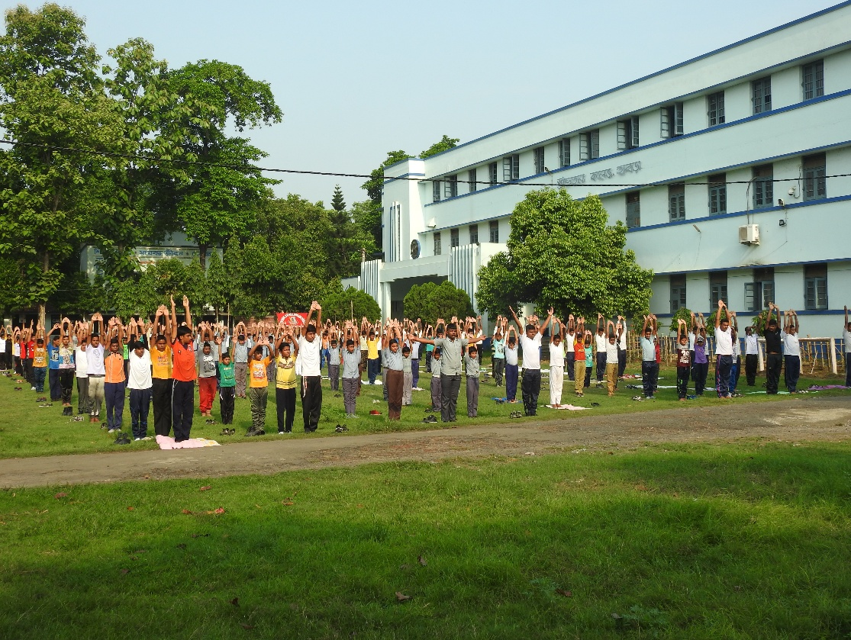
YOGA TRAINING, 21ST JUNE 2018 AT OUR COLLEGE GROUND.

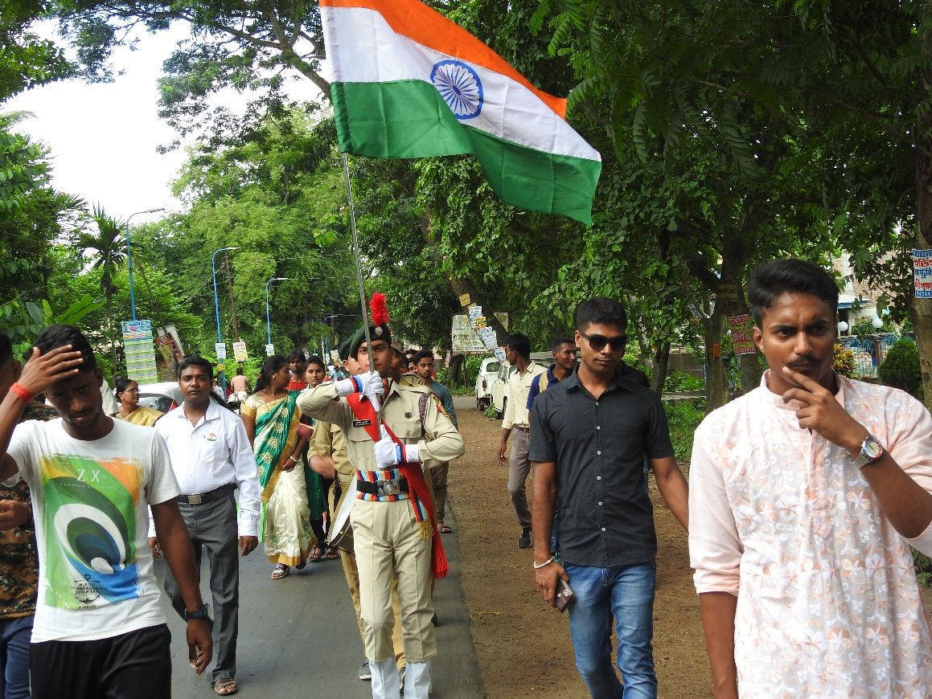
RALLY WENT OUT IN THE LOCALITY ON 15TH AUGUST 2018.
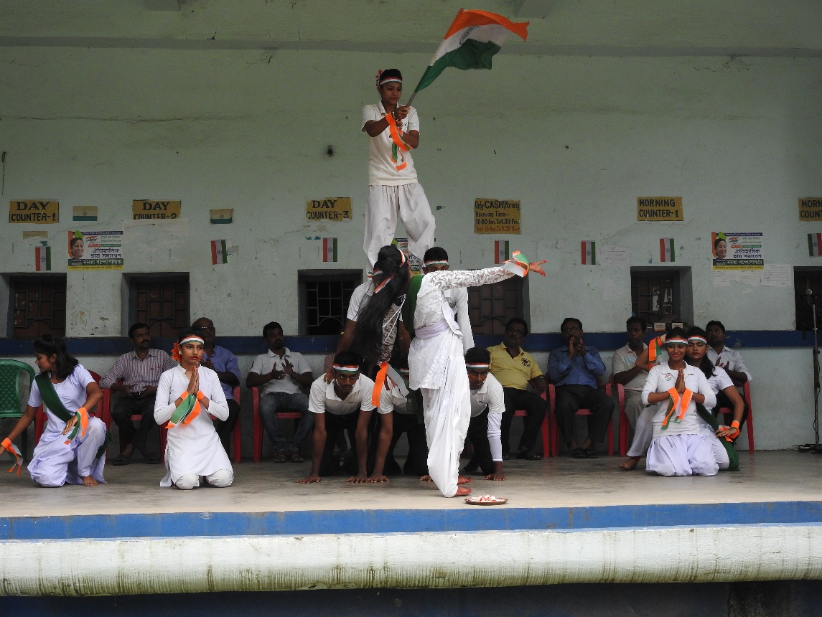
NCC CDTS PERFORMING CULTURAL PROGRAMME ON 15TH AUGUST 2018.

